Outcomes of Workshop 1 – the EDiCT map

Empathic understanding in conflict transformation: A goal
We found it helpful to describe ‘empathic understanding’ as the goal of changing empathy dynamics in conflict transformation, i.e. how we would like empathy dynamics to work between people involved in conflict.

Empathic understanding has four key characteristics:
- the Other is seen as a complex individual
- and that’s ok – differences are accepted
- the Other is entitled to full human rights
- all involved have ways to deal with the emotional tension generated by 1-3.

Notes: 3. marks out ‘positive peace’ rather than ‘negative peace’. 4. is innovative because conflict transformation models do not concern themselves with emotions

Assumptions and moral commitments
We agreed that we work with starting assumptions / moral commitments around empathy in conflict transformation about the people we work with and the processes:

- An encompassing belief that conflict transformation practitioners make a difference; belief in new possibilities.
- An assumption/belief that a person is more than a label, has (occupies) multiple, shifting identities.
- Moral imagination to see beyond the specific act e.g. of violence, or rejection.
- The belief that it is possible for the conflict transformation practitioner to connect with another identity of a person, i.e. that a person can act/think differently from how they act/think during conflict.
- The belief that talking to that person can support them to connect with others.
- The belief that empathic connection will spread from individuals through a group.
- It is important to have strategies, capacities to deal with emotions generated through all this.

In summary, the conflict transformation practitioner works with a wider vision – about the act, the people involved – and with a certain optimism – that other ways of living are possible and that individuals are more than their violent acts. To this vision and optimism we add assumptions about empathy – that empathic connection is possible between conflict transformation practitioner and people involved in conflict; that empathic connection is possible between people from different sides of a conflict; that empathic connection raises emotions that may not be easy to deal with.

Empathic engagement: Possible steps in analyzing empathy dynamics to plan towards empathic understanding

- Conflict map: to show all actors in a conflict scenario

- Zoom in: a conflict map tends to lump people in groups, but we need to work at more individual level so we zoom in to specific person/people

- Analyse current empathy~dyspathy dynamics in their web of relationships/connections.

- Vision - turn around: Imagine the empathy~dyspathy dynamics otherwise, with fuller empathic understanding; spot possibilities to exploit …

In the case studies, we tried two ways of doing the third step:
Maralal: Force field analysis + current empathy~dyspathy dynamics
The four key characteristics of empathic understanding were turned into questions about the current empathy~dyspathy dynamics between parties to conflict:
- How do various sub-groups and individuals see the Other? (as complex individual? or lumped, distanced?)
- Are differences between parties real or imagined?
- What do the parties want of each as the Other, and how does this fit the goal of full human rights?
- What are people doing with the emotions involved?

Former CAAFAG, Nepal: Analysis of web of relations/influences, breaking down the groups and sub-groups to consider empathy~dyspathy dynamics at individual level.

Next: combine these into a single method?

Case study 1: Maralal, Kenya
- Conflict map – to show all actors in a conflict scenario

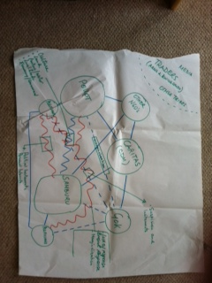

- Zoom in: a conflict map tends to lump people in groups, but we need to work at more individual level so zoom in to specific person/people as Other
We zoomed in on Pokot community and sub-groups within the community: elders; morans; children; unmarried women; etc.
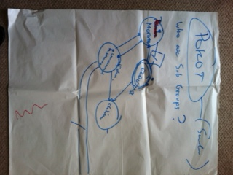

- Force field analysis + current empathy~dyspathy dynamics

The four key characteristics of empathic understanding turned into questions about the current empathy~dyspathy dynamics between parties to conflict:
- How do various sub-groups and individuals see the Other? (as complex individual? or lumped, distanced?)
- Are differences between parties real or imagined?
- What do the parties want of each as the Other, and how does this fit the goal of full human rights?
- What are people doing with the emotions involved?
(the blue writing)

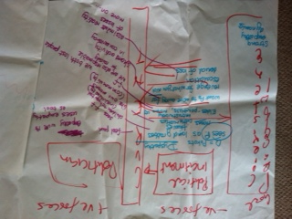

- Turn around: Imagine the empathy~dyspathy dynamics otherwise, with fuller empathic understanding; spot possibilities to exploit
The purple writing on the above are the actions taken by conflict transformation team to change empathy~dyspathy dynamics:

 |  | current empathy~dyspathy dynamics | changes in empathy~dyspathy dynamics
i. | Pokot morans are seen by Samburu as | land grabbers, thieves, cattle rustlers | - feel pain like we do; we both lost people  - are like our own morans  - met and known face-to-face as individuals
 | Pokot elders are seen by Samburu as | - untrustworthy,  - powerless,  - encourage morans to raid | - we are also responsible for raiding
ii. | differences | commonalities not seen | commonalities in community structure and roles, in losses, responsibility
iii. | solutions wanted and human rights | - the Pokot should move far away  - we want revenge for what happened | - shared activity in conservancy
iv | emotions | - escalation of violence  - denial of loss | - assimilate reality of losses  - move on

Case study 2: Former CAAFAGs, Nepal
- Conflict map – to show all actors in a conflict scenario

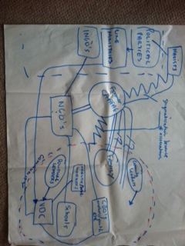

- Zoom in: a conflict map tends to lump people in groups, but we need to work at more individual level so zoom in to specific person/people (Self)

an individual former CAFFAG

- Web of connections and the empathy~dyspathy dynamics of each. Analysis of relations/influences, breaking down the groups and sub-groups to consider empathy~dyspathy dynamics at individual level.

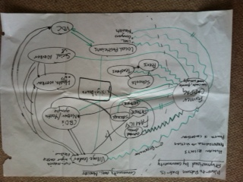

- Turn around: Imagine the empathy~dyspathy dynamics otherwise, with fuller empathic understanding; spot possibilities to exploit

